RedR UK Coaching Services
  - Overview
What is Coaching?
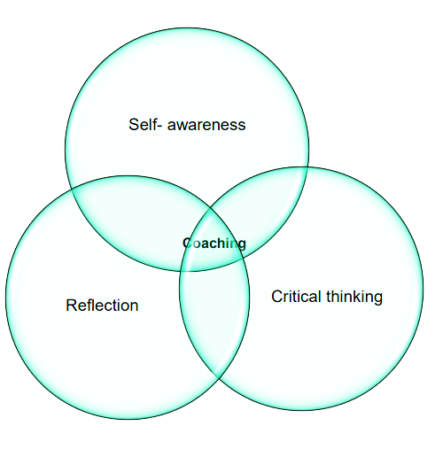
Coaching is a form of one to one support provided to individuals to help them perform more effectively in their roles. Coaches listen to issues raised by humanitarians and support them to reflect upon and draw out their own experience and knowledge to make decisions and work effectively.
The role of the coach is to:
- Clarify participant goals
- Encourage participant self-discovery
- Elicit participant-generated solutions
- Support participants to achieve progress
- Encourage participant accountability
Benefits to individuals include:
- Development of self-awareness
- Improved decision making and performance
- Greater clarity in setting goals and success in achieving them
- Increased ownership and responsibility towards goal areas
- Increased ability to identify solutions to work-related issues
- Improvement in desired skills or behaviours
- The opportunity to correct behaviour/performance difficulties
- Increased openness to personal learning and development
Benefits to organisations can include:
- Fosters a more complete use of individual talents and potential
- Increases organisational performance and productivity
- Facilitates positive change to management styles and approaches
- Increases staff creativity, reflection, and learning
- Improves relationships and motivation between individuals and departments
- Supports organisational change processes
- Demonstrates an organisational commitment to employee professional and personal development
“It was fantastic to talk through updates with someone unrelated to the organisation... an outside perspective enabled me to gain clarity and develop solutions to some issues. The coaching process itself helped me to be more motivated and productive, and that translated across to my other work.”
- RedR UK Coachee (SIIM Project)
Coaching is organisation led and participant driven, with the coach as the catalyst for change.
Coaching enables organisations to fulfil their strategic objectives, while also accounting for the personal development needs of employees.
The resulting two-way relationship brings significant benefits for both individual and organisation.
About RedR UK
RedR UK develops the knowledge and skills of individuals and organisations for more effective humanitarian action.
“The coaching space gave [individuals] the time and means to pro-actively plan and seek out new approaches, rather than reacting to circumstances and feeling limited by them. Reflection time is scarce in the sector, and the importance of it is often undermined in the learning environment; prioritising it allows for deeper learning and reflection of the variety of options open to coachees” – RedR UK Coach (ADCAP Project)
Our training interventions are participatory, based on practical learning from recent disasters, and delivered by expert trainers with humanitarian field experience.
From our regional programme offices in the UK, Jordan, Kenya, and Sudan, we offer tailormade training, coaching and mentoring, facilitation, learning needs assessments, policy reviews, security assessments, training design and project evaluations.
Last year we trained 7,940 aid-workers in 30 countries. Our members work at the frontline of humanitarian response for a wide variety of NGOs and UN agencies, and over 200 of our members responded to humanitarian crises in the last year last alone.
We have more than 20 years’ experience in developing the capacity of humanitarians. By 2019 we will have supported more than 35,000 individuals and 1,000 organisations, 80% of which will be national organisations in disaster affected countries.
RedR UK’s Coaching Experience
RedR UK applies coaching as a part of capacity development interventions and organisational-level change programmes. Our professional coaches have extensive humanitarian experience and come equipped with the sector knowledge and the contextual understanding needed to directly support NGOs and their staff.
To date, RedR UK has coached over 350 humanitarian practitioners. We can provide a range of coaching services, including:
- Leadership Coaching: Coaching over 160 middle and senior management of NGOs in leadership and management skills in Jordan, Lebanon, Kenya and Ethiopia.
- Key Change-Makers: Coaching eight Inclusion Advisors on the implementation of the sector wide Age and Disability guidelines for the humanitarian sector. Coaching 21 NGOs and INGOs to improve organisational and sector-wide security and information management.
- Organisational Development: Providing one-to-one coaching and a dedicated coaching week to the leadership staff of a network organisation, as part of an 18-month project designed to increase local capacity and drive development across the organisation’s 26 member countries.
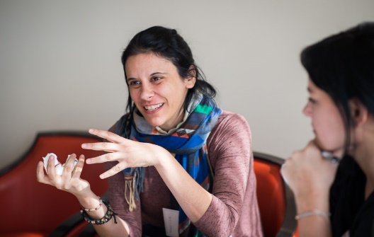
- Meeting Quality Standards: Delivering coaching to fourteen organisations as part of a project to implement sector-wide learning standards.
- Coaching to Reinforce Training: Open and tailored course participants can receive additional coaching to support their application of learning in practice on-the-job.

Coaching with RedR UK – How Does it Work?
Step One - Review organisational and individual needs: RedR UK will work with you to complete an organisational coaching needs assessment, including scope (participants and level of support needed – we recommend a minimum of five sessions per coachee), and any specific departmental or strategic change areas you would like the coaching to focus on. Participants will also be asked to complete a self-assessment form to share their individual focus areas and goals.
Step Two - Selection and matching: Participants will be selected based on the criteria discussed with the organisation. RedR UK will carefully match the Coachee with a suitable Coach based on the Coach’s professional background and context experience, with a focus on the specific strengths and weaknesses raised in the learning needs assessment.
Step Three - Individual coaching agreements: After an introductory coaching session, both the Coach and Coachee confirm the suitability of the coaching match, the timeline and format the coaching will take, as well as the expectations of both parties and the steps to follow if either fails to adhere.
Step Four - Implementation support: Coaching can be conducted face-to-face, or remotely via Skype or other online platforms. A RedR UK staff member will also be available to support the Coach and Coachee in case of any communication issues or other challenges.
Step Five - Monitor progress: During the coaching programme, RedR UK will monitor the progress of the coaching relationships overall. This includes tracking the number of sessions that take place and the types of issues discussed, as well as a mid-way review by both the Coach and Coachee. RedR will then share and discuss these findings with you.
Step Six - Wrap up and evaluation: At the end of each individual coaching trajectory, the Coachee and Coach both complete an evaluation form to reflect on the learning and achievement of the goals set at the start. RedR UK will also review and share its findings on the effectiveness and impact of the coaching programme as a whole.
Quality Assurance
“The coaching process itself helped me to work on deadlines and to be productive. Following the coach’s recommendations, I also asked questions to other departments to have better answers on legal, IT, communication issues.” – RedR UK Coachee (SIIM Project)

Throughout the coaching process, RedR UK uses a range of mechanisms and tools to monitor, adapt, and evaluate the programme. Monitoring tools are tailored to the specifics of each coaching programme, based on the organisation’s overall objectives. Evaluations can assess any chosen area from implementation of key competencies (e.g. decision-making) to improved performance in the workplace (e.g. adhering to quality standards).
The content of all coaching sessions is confidential to ensure that Coachees feel comfortable openly discussing any challenges they may be facing within their work or personal lives. While we will not share individual data on the content of discussions, RedR UK does share the aggregated, anonymised data, and overall findings with the organisation.
Contact Us
UK/Europe Office: +44 (0) 207 840 6000 | info@redr.org.uk
Jordan/MENA Office: +962 (0) 6 462 6227 | middle.east@redr.org.uk
Kenya/SSA Office: +254 (0) 790 200 174 | SSA.courses@redr.org.uk
Sudan Office: +249 (0) 15488 4278 | sudan.admin@redr.org.uk
Annex A: Coaching and Capacity Development – Project Examples
The Context Programme
RedR UK was an implementing partner for Oxfam International and the Context Programme from 2015-2017. The project contained two long-term learning streams - Management and Leadership, and Core Humanitarian Skills - designed for middle to senior management, and field level staff respectively.
Coaching was a central component of the project. Upon completion of the training, Management and Leadership participants received three hours of individual coaching, and subsequently went on to deliver one-to-one coaching to the Core Humanitarian Skills participants. Over three years, the programme worked with 320 participants who received over 500 hours of coaching, 75% of participants rated their coaching as very beneficial or extremely beneficial.
“I applied some personal action points from the action plans, such as … changing my ways of expressing and reducing stress by creating a new communication protocol within the team and with some stakeholders”.
– Context Core Skills Participant, Lebanon (Context Programme)

Security Incident Information Management Project (SIIM)
RedR UK led a consortium on the Security Incident Information Management Project (SIIM) from 2016-2018. The project has worked to improve the collection, sharing, and analysis of security incident data across the humanitarian sector, providing context-specific actionable intelligence to support field and HQ level decision making.
RedR UK worked directly with 21 national and international organisations around the world to identify gaps in their security mechanisms and implement processes to address them. Senior Managers, Security Professionals, Human Resource and Programme Personnel received in-person and online training to develop practical solutions. Following the training, participants received 6 hours of individual coaching, resulting in embedded organisational change.
“[The most useful part of the coaching was having] the time to sit, and discuss at length, a security challenge facing the organisation with a dedicated mentor/coach. This has been very helpful to focus my mind and enabled me to reflect on my work. Another perspective on the organisation is great. Also, it has helped invigorate me in facing and overcoming organisational challenges.”
- RedR UK Coachee (SIIM Project)

The Age and Disability Capacity Project
From 2014-2018, RedR UK supported the ADCAP consortium in the creation and implementation of a set of minimum standards for Age and Disability Inclusion in Humanitarian Action.
To support the implementation and evaluation of the standards, RedR UK trained and deployed eight inclusion advisors to work directly with the participating NGOs. The advisors received 49.5 hours of coaching, with a focus on six broad themes within their work: Personal, Influencing and Driving Change, Internal Issues, Strategy, Capacity Development, and Reflections.
“Action plans actually transform training [and coaching] into practical application and action.” - Coachee Line Manager (ADCAP Project)

Annex B: Sample of RedR UK Coach Profiles
Senior Management Coaches
A. Clark is an accomplished Trainer and Coach with an extensive background working with groups and individuals in the international humanitarian, development, and business sectors. As a Coach, A. Clark specialises in helping humanitarian staff balance the demands of full workloads, while maintaining efficiency and good working relationships. He has coached managers in organisations including CAFOD, VSO, Amnesty International, and HIV/AIDS Alliance. In addition, he has privately coached over 300 individuals.
T. Dines is an experienced Executive Manager, Trustee, Consultant, Trainer, and Coach in the international humanitarian and development sectors. He has extensive programme management experience having regionally managed six African country programmes and led an expansive strategic development process. T. Dines recently coached the Director of a prominent international aid agency to help clarify the strategic direction of the organisation. He has also run a coaching skills programme and provided on-going coaching support to global child protection specialists in Save the Children. In South Asia, he provided coaching and organisational development services to various emergency response agencies.
Humanitarian and Security Coaches
S. Blakemore has a professional background in Human Resource Management, and over 30 years of experience in the field of training, group facilitation, and coaching with humanitarian and development organisations. With a well-established reputation for taking a creative approach, he has designed and led a wide range of courses, workshops, and conferences for INGOs including NRC, IRC, and Oxfam.
C. Walker is a seasoned humanitarian trainer, facilitator, consultant, coach, and mentor. He has built his career working as a programme manager and expert consultant for INGOs in African conflict regions and Haiti. C. Walker has worked as an Associate Trainer with RedR UK since 2014, delivering training and coaching across his areas of specialisation including Staff Safety and Security, Field Logistics, People and Project Management in Africa, Europe and Asia.
K. Wooster is a trainer, coach, and consultant with over 25 years’ experience working for international humanitarian NGOs. She has supported numerous humanitarian agencies to reach their potential through research, organisational development, facilitation, and training. During her humanitarian career, K. Wooster served as the Country Director for MercyCorps in Turkey and has worked in over 30 countries across Africa, Asia, Europe and South America.
HR and Financial Management Coaches
J. Cammack has 25 years of experience as a Trainer, Coach, and Facilitator in financial management for executives, managers, staff, and trustees internationally. He is an expert Coach for individuals in management and financial management, he supports coachees and NGOs to build their capacities in strategic and operational financial management. J. Cammack is proficient in developing cross-cultural communications between departments, he also works with organisations to ensure they are fit for funding.
J. Tordoff is a senior HR consultant, Trainer, and Coach with over 18 years of professional experience working for a number of international NGOs. She is experienced in organisational development issues and significant change management projects, and is an expert in developing HR policies and strategies under different humanitarian conditions. J. Tordoff has extensive international experience, having worked in Mozambique, Sri Lanka, Afghanistan, Bangladesh, India, Nepal, and Pakistan.

